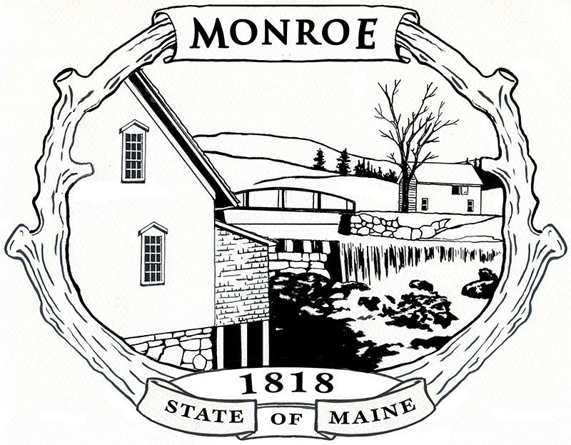

Property Improvement and Use Checklist

Town of Monroe, Maine
Prepared by the Monroe Planning Board

Prepared: August 5, 2021

This checklist is provided as a guide to assist property owners in determining what applications, inspections, and permits are required for a change in the use of their property; new construction; and any other changes or improvements on property within the Town of Monroe.

DISCLAIMER: This checklist is provided as a guide. It is not intended to be a requirement in itself nor does it necessarily reflect all requirements that may exist. Property owners are encouraged to seek professional guidance to assure all State and Local requirements are met. Recommended changes or corrections to this checklist should be submitted to the Monroe Planning Board.

Intent to Build Form:

Purpose: To update the Town of Monroe property valuations.
Scope: All improvements to property in excess of $2,500.00 in value. Repairs to existing structures are excluded.
Applicability: All property improvements within the Town of Monroe.
Source for Forms/Applications: Monroe Town Clerk or On-Line at Intent to Build Form
Fees: None
Est. Process Time: Not Applicable (N/A)
Special Instructions: Contact the Monroe Town Clerk to start the process. Submit completed form to Monroe Town Clerk prior to start of construction.
Reference: Town of Monroe Requirement
For Further Information Contact: The Monroe Town Clerk. Telephone (207)525-3515

Compliance with Monroe Subdivision Ordinance:

Purpose: To assure proposed subdivisions meet the requirements of the Monroe Subdivision Ordinance.
Scope: All proposed subdivisions.
Applicability: All property within the Town of Monroe.
Source for Forms/Applications: Monroe Town Clerk.
Fees: Varies. Depends on the number of lots being proposed for development.
Est. Process Time: 60-90 days for approval.
Special Instructions: Contact the Monroe Town Clerk to start the process. Proposal must be prepared in accordance with the Monroe Subdivision Ordinance. Copies of the ordinance are available at the Town Office.
Reference: Monroe Subdivision Ordinance, Application Form for Subdivision Approval
For Further Information Contact: The Monroe Town Clerk. Telephone (207)525-3515

Compliance with Monroe Shoreland Zoning Ordinance:

Purpose: To assure any changes to the shoreland of a major stream or pond as defined by the Maine State Rules meet the Monroe Shoreland Zoning Ordinance.
Scope: All shoreland property as defined in the ordinance; up to 250 feet of the shoreline of a major stream or pond.
Applicability: All property within the Town of Monroe.
Source for Forms/Applications: Monroe Town Clerk.
Fees: $5.00 for Application and copy of the Monroe Shoreland Zoning Ordinance.
Est. Process Time: Review and approvals take 30-45 days.
Special Instructions: Contact the Monroe Town Clerk to start the process. Applications and copies of the ordinance are available at the Town Office. Submit completed applications to the Monroe Town Clerk. Planning Board review, selectmen sign application. Applications must be approved prior to making changes to impacted property. Includes any proposed alteration of the flora in addition to any construction.
Reference: Monroe Shoreland Zoning Ordinance Monroe Shoreland Zoning Map
For Further Information Contact: The Monroe Town Clerk. Telephone (207)525-3515; Mr. Randy Hall, Monroe Code Enforcement Officer, Telephone (207)234-4006

Driveways Connected to State and Town Roads:

Purpose: To assure driveways connected to state and local roads meet State and Town standards.
Scope: All privately owned driveways providing access to State and Town public roadways.
Applicability: All property within the Town of Monroe.
Source for Forms/Applications: For State Road access, permit applications can be obtained online here. For Town roads, contact the Town Clerk for application information.
Fees: None
Est. Process Time: Not Applicable (N/A)
Special Instructions: For State Roads, permit application and State Telephone numbers are available online at above link. For Town Roads, Contact the Monroe Town Clerk to start the process.
Reference: For State Roads - Maine State Law (Title 23 M.R.S.A. § 704), For Town Roads, Town Rules.
For Further Information Contact: Download Maine Guide for State Roads. For Town Roads, Selectboard serves as the Monroe Road Commission. Contact the Monroe Town Clerk for further information and to start the approval process. Telephone (207)525-3515.

Waste Water Disposal Plan/Permit:

Purpose: To assure proper disposal of subsurface waste water in accordance with Maine State Law.
Scope: All houses, camps, or other buildings which will allow for the collection and disposal of subsurface waste water. Includes structures with hand pumped or hand carried water. Includes temporary dwellings such as tents, trailers and RVs occupied for 120 days or more.
Applicability: All permanent or occupied structures as described above within the Town of Monroe.
Source for Forms/Applications: Monroe Town Clerk.
Fees: Varies
Est. Process Time: Varies. May take up to 4-5 weeks.
Special Instructions: Contact the Monroe Town Clerk to start the approval process. Application for permit provided by a licensed site evaluator. Soil tests must be conducted and waste water systems must be designed by licensed site evaluators. Compliance with permit verified by the Monroe Plumbing Inspector. Town office has names of site evaluators and a copy of the code.
Reference: 10 CMR 144 Chapter 241; Maine Title 30A Chapter 185
For Further Information Contact: The Monroe Town Clerk. Telephone (207)525-3515; Mr. Randy Hall, Monroe Plumbing Inspector, Telephone (207)234-4006

Plumbing Permit:

Purpose: To assure plumbing systems meet Maine State Code and to facilitate inspection of new and altered plumbing systems.
Scope: All structures with installed plumbing systems.
Applicability: All permanent or occupied structures within the Town of Monroe.
Source for Forms/Applications: Monroe Town Clerk.
Fees: Varies
Est. Process Time: Varies
Special Instructions: Contact the Monroe Town Clerk to start the process. The Plumbing Inspector will initiate the permit and schedule all inspections. Several days notice may be required for scheduling inspections.
Reference: Maine Title 30A Chapter 185
For Further Information Contact: The Monroe Town Clerk. Telephone (207)525-3515; Mr. Randy Hall, Monroe Plumbing Inspector, Telephone (207)234-4006

Electrical Service Permit:

Purpose: To allow Central Maine Power to complete electrical hook up to new service entrances. Allows town to review requests to prevent illegal subdivisions. Assures compliance with NEC.
Scope: All properties requesting hook up into the Central Maine Power (CMP) grid. All structures with permanently installed electrical wiring and fixtures.
Applicability: All permanent or occupied structures within the Town of Monroe.
Source for Forms/Applications: Monroe Town Clerk. CMP Form 1190, Certification of Compliance with Subdivision and Shoreland Zoning Requirements.
Fees: None
Est. Process Time: N/A
Special Instructions: Contact the Monroe Town Clerk to start the process. Submit completed application to Monroe Town Clerk. Allow seven days for review by the Monroe Planning Board. The State of Maine requires that all electrical installations and work be done in accordance with the NEC. Wiring completed by the homeowner in lieu of completion by a licensed electrician requires a certificate of inspection. See Below - Compliance with National Electrical Code (NEC).
Reference: Maine Title 32, Chapter 17, Subchapter 1, Section 1102
For Further Information Contact: The Monroe Town Clerk. Telephone (207)525-3515; Mr. Randy Hall, Monroe Code Enforcement Officer, Telephone (207)234-4006

Compliance with National Electrical Code (NEC):

Purpose: To assure all structural wiring is in compliance with the National Electric Code (NEC).
Scope: All structures with permanently installed wiring and fixtures. All structures being hooked up to the CMP grid.
Applicability: All structures in the Town of Monroe.
Source for Forms/Applications: Maine State Website
Fees: Not to exceed $100 for certificate and inspection. See Maine State website for details.
Est. Process Time: Varies
Special Instructions: No certificate required for single family dwellings wired by a licensed electrician. Homeowners electing to complete their own wiring require a state issued certificate documenting inspection by a state inspector or licensed electrician. See state website for specific details.
Reference: Maine Title 32, Chapter 17, Subchapter 1, Section 1102
For Further Information Contact: The Monroe Town Clerk. Telephone (207)525-3515; Mr. Randy Hall, Monroe Code Enforcement Officer, Telephone (207)234-4006

Compliance with NFPA 101 Life Safety Code:

Purpose: NFPA 101®:Life Safety Code® (NFPA 101), addresses minimum building design, construction, operation, and maintenance requirements necessary to protect building occupants from danger caused by fire, smoke, and toxic fumes.
Scope: All structures in the Town of Monroe.
Applicability: NFPA 101®:Life Safety Code® (NFPA 101) standards are advisory in nature at this time.
Source for Forms/Applications: Not Applicable (N/A)
Fees: None
Est. Process Time: Not Applicable (N/A)
Special Instructions: None
Reference: State Fire Protection Requirements are listed at https://www.maine.gov/dps/fmo/fire-service-laws/nfpa
For Further Information Contact: Mr. Randy Hall, Monroe Code Enforcement Officer, Telephone (207)234-4006

